Charuka Kavinda

[Ckavinda57@gmail.com](mailto:Ckavinda57@gmail.com)

Contents

About me 3

Introduction 3

Business Background 3

Stakeholders 3

Requirements 3

Client Requirements 3

Functional Requirements 4

Non-functional requirements 4

Requirements Methods 4

Scope 4

Analysing Tools 4

Project Plan 5



1 Cover Photo

Reflective Review

# About me

I am an undergraduate 2nd-year software engineering student at Cardiff metropolitan university.

Name: Charuka Kavinda.

Student ID: CL/BSCSE-CMU/01/10

# Introduction

ABC institute is one of the best institutes in Sri Lanka and has a long-term history of reputation. But in this technological era, they didn't adapt to the internet culture very well. That’s the reason stuck with manual student management or the old system. Developing a new online system should definitely fulfil the online aspect of the ABC Institute.

# Business Background

The current system having in the ABC institute is all processes are running by a manual process. Program coordinator to student and marketing staff all activities are done by the manual system as registering updating profiles and assessment submission and also payment and many more done with the manual process.

# Stakeholders

In ABC institute students, program managers, and marketing staff can be identified as internal stakeholders. The government would be external stakeholders in this scenario.

# Requirements

## Client Requirements

The client didn't have an exceptional knowledge about requirements. But he mentions basic requirements that are currently had in manual systems and basic requirements in general. For Example student login, assignment submission, student payment, registering has mentioned the client.

## Functional Requirements

• Program Coordinator – Creating and managing user accounts, view submission details, marks details of student details, if necessary update and delete student records and submission details.

• Student – add, view, update submissions, payment management and manage their personal details.

• Marketing staff – add, update and view student records including student registrations.

## Non-functional requirements

* Maintenance- to maintain the system after the development
* Security - to give a guarantee about the security of the system.

# Requirements Methods

For this project to gather requirements, I have used 3 methods to approach the scenario.

* Interview- interviewing the main client was the first approach and the developer can understand the direct idea that has in the client's mind about the problem.
* Brainstorming - this institute has a huge amount of members and getting ideas from them can be very specific to the institute and solution
* Focus group- this method can be used to get direct ideas from specific groups. For example students, management staff, lectures, and program coordinator.

# Scope

According to the finalized time period, this project shows the developer to scope the boundaries of this project.

1. Managing the details of Students.
2. Managing all the details about program coordinating.
3. Managing details about the Marketing staff.
4. Managing details about Payment process.

# Analysing Tools

Creating Student Management system Compare with other Projects this one is not a high-risk Project. But this project has only a certain amount of time. With these circumstances, I have decided to choose an Agile SLDC model to work with this project.

# Project Plan

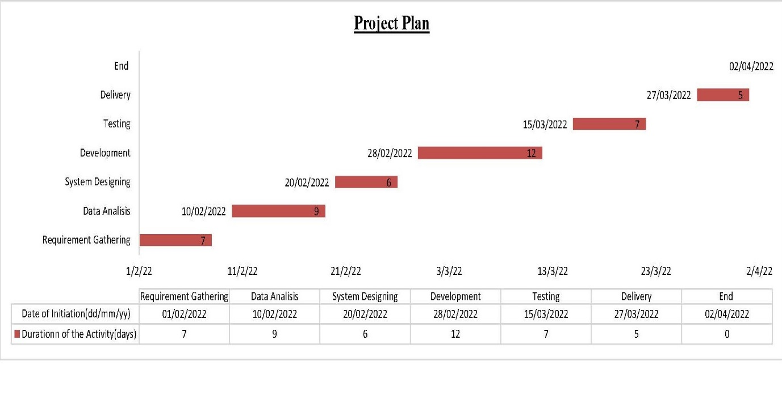

2 Project Plan